www.modernfatherhood.org
Parental Working in Europe: Methodology

Authors: Matthew Aldrich, Sara Connolly, Margaret O’Brien, Svetlana Speight and Robert Wilshart

These Research Notes provide an overview of changes in parental working in Europe over the period 2001 to 2013. There are four topics that are explored in detail: Working Patterns, Working Hours, Non-standard Hours and Underemployment. Analysis was undertaken for all the topics in each of the 17 countries for which data is available. Where a country is not mentioned within a research note, no statistically significant changes have taken place.

Data
The data used in the analysis comes from the European Labour Force Survey (EU LFS). The European Labour Force Survey is conducted in the 28 European member states, 2 candidate countries and 3 countries of the European Free Trade Association (EFTA).
The data was selected to include only couple parent households – aged 16-64 with at least one co-resident dependent child. These children can be biological, step children or adopted. Parent households where children have left the household are excluded. Biennial data is presented for the period 2001 to 2013.
Data restrictions in some countries prevents an analysis being undertaken. Denmark provides basic data, but no detailed data as this information is collected by interviews and cannot be collated to the EU LFS data. Neither basic nor detailed household codification data for Sweden, Iceland, Norway and Switzerland is supplied to the EU LFS. Finland uses special household sub-samples, and therefore this data cannot be used.
In addition to these six countries, which cannot be analysed due to data restrictions, some countries do not provide large enough samples to give a reasonable analysis of changes in working household patterns. Countries were excluded if they did not meet a threshold of 50 or more households in more than three separate household typologies (details of which can be found below) in the base year for that country. These countries are: Estonia, Cyprus, Latvia, Lithuania, Luxembourg, Malta, and Slovenia. This leaves 17 countries to analyse. In addition, within individual topics analysis is not undertaken if a minimum sample size of 50 is reached.

Household Classifications
We categorise households into ten different types of working arrangement. There are four ‘standard’ household types, these are: dual full-time earner households, standard 1.5 earner households (where the father works full-time and the mother works part-time), male sole breadwinner households and non-earner (or workless) households. There are also six ‘non-standard’ household types: non-standard 1.5 earner households (where the mother works full-time and the father part-time), female sole breadwinner households, dual part-time earner households, male sole part-time earner households, female sole part-time earner households and households where at least one partner’s working hours vary too much for them to be assigned any other household classification (these are named ‘other’ households). This is summarised in Table 1 below.

Table 1 – Household Working Patterns
Type | Description | Working hours of father | Working hours of mother
Dual earner | Father full-time, mother full-time | Greater than or equal to 30 hours per week | Greater than or equal to 30 hours per week
The standard 1.5 earner | Father full-time, mother part-time | Greater than or equal to 30 hours per week | Less than 30 hours per week
The non-standard 1.5 earner | Father part-time, mother full-time | Less than 30 hours per week | Greater than or equal to 30 hours per week
The male breadwinner | Only father works | Greater than or equal to 30 hours per week | Female not employed (unemployed or inactive)
The female breadwinner | Only mother works | Father not employed (unemployed or inactive) | Greater than or equal to 30 hours per week
Dual part-time | Both partners work part-time | Greater than 0, less than 30 hours per week | Greater than 0, less than 30 hours per week
Male sole part-time | Only father works, part-time hours | Greater than 0, less than 30 hours per week | Mother not employed (unemployed or inactive)
Female sole part-time | Only mother works, part-time hours | Father not employed (unemployed or inactive) | Greater than 0, less than 30 hours per week
Neither working | No partner working | Father not employed (unemployed or inactive) | Mother not employed (unemployed or inactive)
Other | At least one partner working but doesn't have usual hours | (Either) Father works, but hours vary drastically | (Or) Mother works, but hours vary drastically

For the purposes of these short briefing papers, the six non-standard working arrangements have been grouped together into a single category.

Country Groupings
There are four key groups that had similar employment patterns, and can be categorised by their experience of the recession and geographical location. The four country groups are: Growth, Severe Recession, Recession (Northern and Western) and Recession (Eastern).
Growth countries are countries that have grown despite the Great Recession: Germany and Poland. Germany grew on average by 2.0% a year between 2010 and 2014, and Poland grew on average by 3.1% over the same period.
Severe Recession countries are EU27 countries that have been severely impacted by the recession and the sovereign debt crises. These countries have experienced falls in output and large increases in unemployment: Greece, Italy, Ireland, Portugal and Spain.
Recession (Northern and Western) countries are EU27 countries that have experienced recession: Austria, Belgium, France, the Netherlands and the UK.
Recession (Eastern) countries are EU27 countries that have joined the EU since the 2004 and 2007 enlargements and also experienced the recession: Bulgaria, the Czech Republic, Hungary, Romania and Slovakia.
Table 2 below presents annual GDP growth rates for each country for the period 2001-2013. The chart displays growth over the recessionary period (2007 – 2012), and whether growth was positive (blue) or negative (red) in each year.
Table 2 – GDP growth, 2001-2013
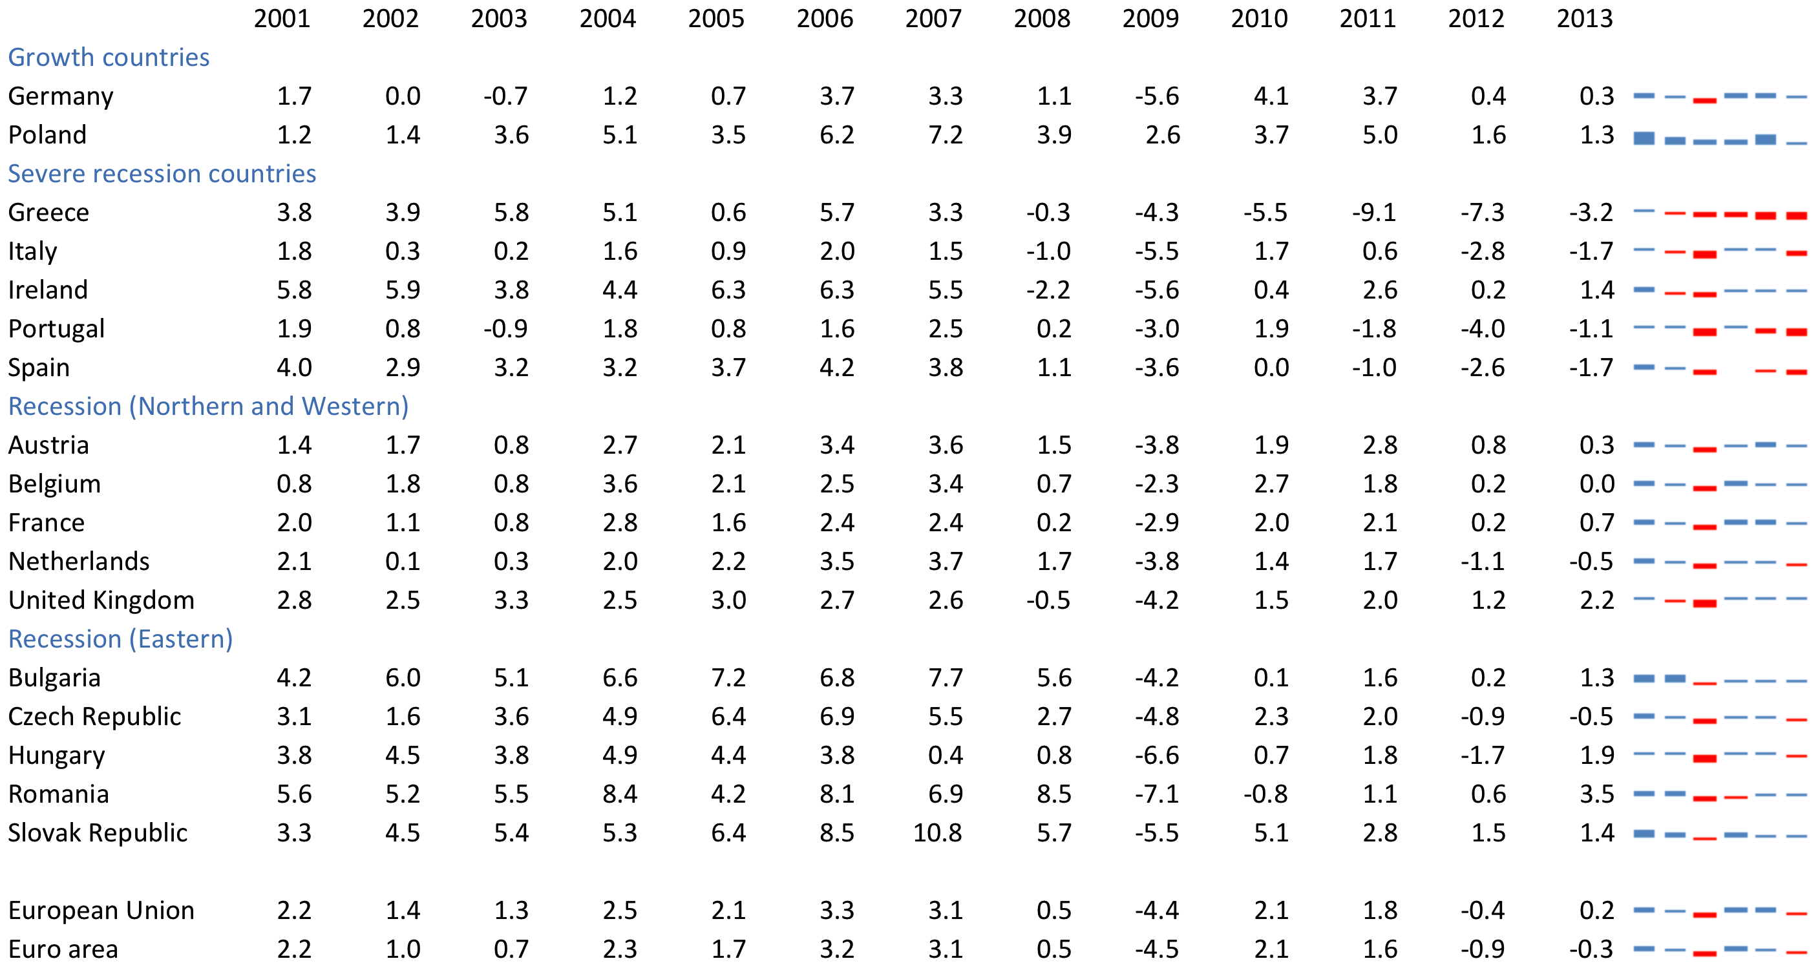

Significance Tests
Significance is calculated using Welch’s ‘t’ tests for changes in means between the base year (the earliest year for which sufficient data is available in that country – this can be any year from 2001 onwards) and the 2013. Significance at the 5% (**) and 1% (***) levels are reported. Some changes may be significant at the 10% level, however these are generally not reported.

Parental Working in Europe: Household Patterns of Work [hyperlink]
Parental Working in Europe: Working Hours [hyperlink]
Parental Working in Europe: Non-standard working hours [hyperlink]
Parental Working in Europe: Underemployment [hyperlink]

World Bank, GDP Growth (annual %), 2015, Link: http://data.worldbank.org/indicator/NY.GDP.MKTP.KD.ZG , accessed 07/09/15

